Saint Augustin Secondary School
Level: 1st year scientific stream
Second Term exam
Read the text then do the following examples: 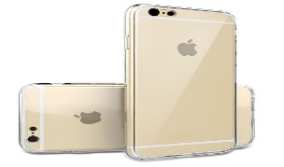 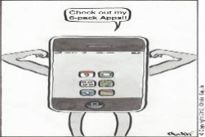
The original iPhone was released on June 29, 2007. It was a mobile phone that had many capabilities
and could connect to the Internet. The iPhone had a camera, a video camera, an MP3 and video player, and was a mobile phone. It also had e-mail and text messaging. The iPhone also had a touch screen with a virtual keyboard and buttons. The company that made the original iPhone is called Apple, and it spent $150 million developing the phone.
The original iPhone has been updated several times. In July 2008, Apple introduced the iPhone 3G. In June 2009, they introduced the iPhone 3GS. Over 1 million iPhone 3GS phones were sold within 2 days of its release. One year later, the iPhone 4 was released, and 1.7 million people bought one in the first 3 days. The next iPhone was the iPhone 4S. Then on September 21, 2012 Apple released the iPhone 5. This was followed by the iPhone 5S and iPhone 5C. The latest iPhones are the iPhone 6 and iPhone 6 Plus. These were both released on September 19, 2014.
Source: http://dreamreader.net/
1) The text is: a- Internet article b- a letter c- a report (0,5pt)
2)Are these statement “true” or “false”: (1,5pt)
- Orange produced the iPhone.
- Apple released only three models of the iPhone.
- The origin iPhone can record videos and play music.

3) Read the text then answer the following questions: (3pts)
a)What are the capabilities of the iPhone?
b) How many customers bought the iPhone 3GS?
- When was the iPhone 6 available in the market?
4) In which paragraph are “the different models of the iPhone” mentioned? §= …… (0,5pt)
5) What or whom do the underlined words refer to? (1,5pt)
Text exploration: (8pts)
5) Find in the text words that are synonyms to: (1pt)
Abilities= §1 …….. modified=§2
6) Find in the text words that are opposites to: (1pt)
Initial=§2 Bought= §2
8) Link each pair with the conjunction: (2pts)
a) IPhone 6 is sophisticated. Everybody dreams to own one. (So… that)
b) The iPhone 3Gs design was so attractive. It has many flaws. (Although)
c) I met Steve Jobs. I thank Steve Jobs for inventing the iPhone. (Whom)
d) Technology have facilitated people’s life. It made them lazy. (however)
7) Rewrite sentence B so that it means the same as sentence A: (1pt)
A: Steve Jobs said: “Our new iPhone will be released soon”
B: Steve Jobs said………………………
A: Steve Jobs says: “IPhone 6 is the best mobile in the market”.
B: Steve Jobs says ……………
9) Classify the following words according to the pronunciation of the final “ed”: (1,5pt)
Introduced – released – updated – helped – worked - recorded
/t/ | /d/ | /id/
10) Complete the dialogue: (1,5pt)
A: …………………….. ?
B: Yes, I know Steve Jobs
A:………………………………?
B: He was born in October 5, 2011
A:………………………………………………?
B: Sorry, I’m afraid I don’t know.
Part II: Written Expression: (5pts)
Topic One: write about the evolution of any invention (computer, telephone, TV, washing machine). Follow the following outline: Introduction- problem- initial solution – invention- problem with the invention – innovation/new invention- conclusion
Topic Two: Use the following information to write a short biography about Steve Jobs the inventor of the iPhone:
Name: Steve Jobs  Date of birth: February 24th, 1955  Nationality: American  Job: entrepreneur and inventor  Education: Reed college | Hobbies: travelling, skiing, listening to music  Invention: the Macintosh computer, iMac, iPod iPhone  Wife: Lawrence Powell  Children: 4 ( 1son and 3 daughters)  Death:October 5, 2011  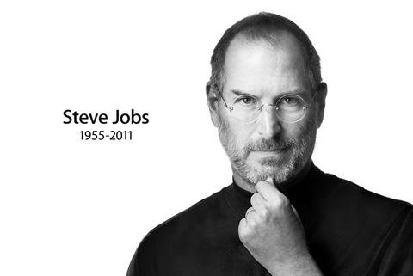
Best Of Luck

