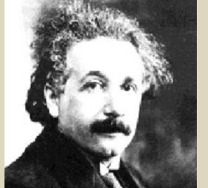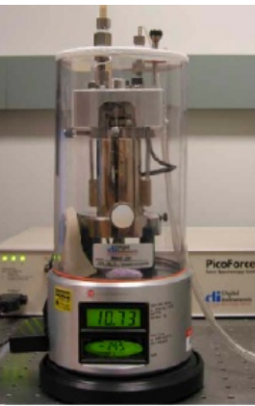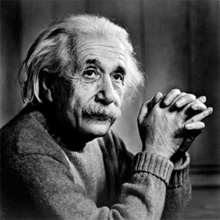

BUDDING SCIENTIST
TECHNOLOGY AND INNOVATION

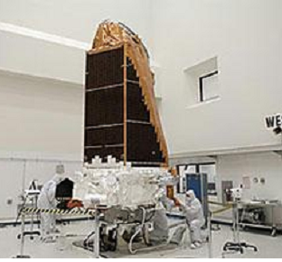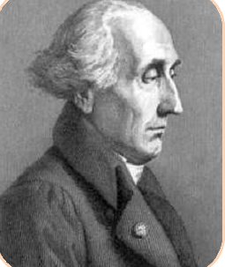

Unit four:BUDDING sCIENTIST
Science and Experiments

Content of the unit
Aim of the unit : By the end of unit two, students should be able to write reports about scientific experiments. Linguistically, the project language structures depend on the use of conditionals especially conditional type "zero" to express conditions, give warnings issuing threats and make promises and predictions.

Dirah high school
Accademic year: 2012-2013 Unit 04:Budding Scientist
Level:2nd year Sequence 01:Discover the language
Text book:getting through Lesson01: Think it over

Learning objectives: pupils will be able to get some of the key words and vocabularies used in the text.

Competencies:
Interactive/interpretive the teacher interacts with his pupils through questions and answers.
Teaching Aids: text book
Extra resources:

Rubrics | Lesson Plan | Aims | T.A
▲Preview  Page 78  Think it over. (Page: 79).  Words to say. (Page 79). | ▲At this stage, the teacher makes students aware of the unit's topic and its project in addition to the principal objectives of the unit. It also includes a discussion about any necessary changes or recommendations.  - Think it over. (Page: 79).  ▲Students are encouraged to observe, analyze and diagnose the drawings and to react to them. With the aid of the teacher, they are supposed to know that these two pictures refer to Arab science during the "the Abbasids period". The teacher and pupils discuss the Abbasids Arab science either depending on students’ knowledge or on the extra reading passage on page 100 in the course book.  ▲A list of words is provided on the right side of the page. The words are mostly science-related concepts. The teacher reads each word individually focusing on the stress and intonation. It is possible, in the meanwhile,  that students repeat along with the teacher,  and later encourages individual readings with a discussion of the meaning. | -To familiarize pupils with the topic of unit four.  -To introduce the unit implicitly.  - To recognize the general notes that the project work would include.

Dirah high school
Accademic year: 2012-2013 Unit 04:Budding Scientist
Level:2nd year(foreign languages) Sequence 01:Discover the language
Text book:getting through Lesson01:Before/As you read

Learning objectives pupils will be able to
- recognize easily the different angles in English and to get some of the key words and vocabularies used in the text.
- make a comparison between the drawings and their measures.
Competencies:
Interactive/interpretive oral interaction between the pupils and the teacher through interpreting the pictures of deferent angles .
Teaching Aids: text book
Extra resources: pictures of different angles

Rubrics | Lesson Plan | Aims | T.A
Before you read.  page 80  As you read.  Page | - The geometrical figure on page 80 represents different angles that students, belonging to a scientific stream, are supposed to recognize easily. The activity gives them a chance to recognize the names of different angles in English, and to get some of the key words and vocabularies used in the forthcoming activities of reading comprehension rubric. Therefore, the teacher encourages them to exchange roles (question vs. answer) to make comparisons between the drawings and their measures.  - Look at the picture and listen to your teacher reading the names of the angles. Then ask and answer questions about how many degrees each of the angles has.  Key :  Students will come to the following conclusions by the end:  *The "acute angle" has less than 90 degrees.  *The "reflex angle" has more than 180 degrees.  *The "right angle" has exactly 90 degrees.  *The "obtuse angle" has more than 90 degrees.  *The "straight angle" has 180 degrees.  Task 01 :: Read the text and check your answers to the previous questions.  *Pupils read the text silently and compare their answers to the questions of pre-reading stage with the correct notes given in the text.  Task 02 : Read the text and again and complete the sentences next to each of the questions below (answer the questions).  Key :  1. Yes, there is a difference. In geometry, the point has no dimension. That is length and thickness. Whereas a dot has length, width and thickness.  02. The author's emphasis is shown by the word {have}.  He says, "A straight line that we draw on paper with a pencil have (not has) width and thickness".  3. The teacher advises his students to revise today's lesson so that they would have good marks in next week's exam. | -Motivating the oral and free expression of pupils in a precise context.  - To familiarize pupils with geometry-related vocabularies.  - Use and practice of comparatives.  To provide students with the correct methodology of answering questions.

Dirah high school
Accademic year: 2011-2012 Unit 04:Budding Scientist
Level:2nd year(foreign languages) Sequence 01:Discover the language
Text book:Getting through Lesson02:Grammar desk
Learning objectives:pupils will be able to use the conditional and its construction and to distinguish between the usage of type 1 and 2.
Competencies::. interactive:pupils consider some sentences then analyse them and at last ,they draw the rule.(interacting orally, interpreting and producing ).
Linguistic:pupils will discover new language components introduced in the 4sentences(p81)
Teaching Aids:text book
Extra resources:handouts given to pupils.

Rubrics | Lesson Plan | Aims | T.A
After reading.  grammar desk, p81).  The rule | The teacher asks the pps some questions :  T: what will happen if I heat ice?  P: If you heat ice, it melts.(general truth) automatically it melts  T : what will happen if you work hard ?  P: If I work hard , I will succeed .so in this sentence we have condition and the result of the condition  If you heat ice, it melts. If+presensimple,present s  if clause main clause  If I work hard , I will succeed.if +present ,future simple  if clause main clause  - With the guidance of the teacher pupils do all the activities in the computer screen-shaped square on page 81.  Key :  a). The result clause of sentence (1) is in the future simple: …will get …, whereas the result clause of sentence (2) is in the present simple: …are ….  b). The condition of sentence (2) is always correct. It is a general fact, but the condition of sentence (1) not always correct; pupils may revise their lessons but fail to get good marks it is only a prediction.  c). The "if" that can be replaced with when are the one of sentence (2) and sentence (4).  2/2 - When two lines cross, the opposite angles are always equal.  4/2 - When there are two points, the shortest distance between them is called a straight angle.  d). The order of sentences according to the degree of certainty is the following:  * Sentences (2 and 4) on the same level.  * Sentences (1 and 3) on the same level.  2- If two lines cross, the opposite angles are always equal.  4- If there are two points, the shortest distance between them is…  1- If you revise today's lesson, you'll get a good mark.  3- If you don't revise your lessons, you may fail.  Conditionals  - We have four types of conditionals:  Conditional Example Rule This type is Used when …….  Type 0 If you heat water, it boils. If + Verb in present simple, Verb in present simple. Describing a general or scientific truth.  Type 1 If she works hard, she will go to university If + Verb in present simple, verb in future (will + stem) A situation is possible to happen.  Type 2 If I were you, I would buy a car. If + Verb in past simple, would + stem A situation is impossible to happen (an imaginary situation).  Type 3 If I had read the question well, I would have taken the best mark. I f + Verb in past perfect, would have + past participle a situation is a regret about an event that had happened in the past | -To identify the conditional clause.  - To recognize the construction and building of the conditional sentences ;( if clause/main clause – main clause/if clause).  - To discriminate and between the usage of the two different types of conditional: Type (I)and type (II) | 1h

Dirah high school
Accademic year: 2011-2012 Unit 04:Budding Scientist
Level:2nd year(foreign languages) Sequence 01:Discover the language
Text book:getting through Lesson 03:Practice

Learning objectives: pupils will be able to
- use the conditional and make differences between the two types(1/0)
- best use’may’and’can
- write conditional sentences express different functions
Competencies: Interactive/interpretive: pupils will re-invest what they have learnt before.
Productive: pupils will write different sentences express the conditional and read it aloud to exchange different examples with classmates.
Teaching Aids: text book
Extra resources: extra exercises in handouts

Rubrics | Lesson Plan | Aims | T.A
Practice  Page 82 | - Task 01 : Put the verbs between brackets into the correct tense.  Key :  a. We shall get wet if it rains.  b. If you boil water at 100 degrees centigrade, it evaporates.  c. If you throw water on fire, it will stop burning.  d. If you take an aspirin, you will feel better.  e. She will feel sick if she drinks from that polluted water.  - Task 02: Put the verbs between brackets in the sentence of column 'A' into the right tense. Then match each sentence with its function in column 'B'.  Key :  A: Sentences B: Functions  A. If you buy two, you will get one free. B. I shall help you do the exercise if you want. C.If you do not stop making noise, I will switch off the TV. D. He will understand if you just explain why you came late. E. If you touch that electric wire, you will get an electric shock. F.If this jacket is the correct size, it will fit you. F) Promise. B) Offer. D) Threat. E) Advice. C) Warning. A)Prediction.  04/Group work. Think about what you’ll do if you pass your exams. Then play a chain game by asking the other group what they will do next. G1: If you pass your exam, we’ll go to Brazil.  G2: What will we do if we go to Brazil?  G1: If we go to Brazil? We’ll visit Maracana Stadium.  Task 05: Make the result clauses in the sentences below sound less categorical by using the auxiliaries 'may' or 'can'. Then write similar sentences as the ones you have obtained.  Key :  a. If you fall down, you may break your arm.  b. That boiler can explode if you put too much pressure on it.  c. He may hurt himself if he has mixes chemical products carelessly.  d. They can fail their mathematics and physics exams if they didn't learn their theorems.  ▲Later, pupils try to write similar examples of their own to make sure they can distinguish conditionals using the three modals 'will', 'can' and 'may'. Some of the best examples could be chosen and written on the chalkboard to encourage creativity.  - or example:  a– You may have an accident if you drive too fast.  b- If you don't pay your taxes on time, you can have a fine.  c- You can ran out of money if you spend too much of it.  d- If you overuse your old car, it may break down one day. | -To practise the use of the conditional clause in context.  -To enable pupils differentiate between the two types of conditional: Type (1) and (0).  -To give pupils additional chances to practise the conditional.  -To make pupils aware of the diverse functions a conditional sentence may have.  -To differentiate between conditional sentences with 'may' and 'can'.  - To recognize the difference in the degree of certainty of conditional sentences using 'may' and 'can'.  - To reinforce the use of 'may' and 'can' in a given language context.

Dirah high school
Accademic year: 2011-2012 Unit 04:Budding Scientist
Level:2nd year Sequence 01:Discover the language
Text book:getting through Lesson04:Write it right

Learning objectives:pupils will be able to write a short description of water properties,using the conjunctions:if,when,as

Competencies: reading and writing:pupils write a descriptive essay about the topic and read and exchange their drafts
interactive:oral interaction by explaining how to write a descriptive essay “water “to make pupils have an idea.
Interpretive:pupils will interpret the given ideas.
productive:pupils write a descriptive essay about the topic and read and exchange their drafts
Teaching Aids: text book
Extra resources:pictures of different uses of water

Rubrics | Lesson Plan | Aims | T.A
Write it right.  Page83 | ▲Inasmuch as the topic is the changes occurring on water, the topic is expected to be familiar to pupils. This makes the upcoming task easier. However, the teacher explains what exactly the task is, and then tells pupils to write a descriptive essay using the notes given and fuse them depending on conditionals with the three modals they have learnt.  -  A possible description:  Like air, water is found almost everywhere. It is familiar to us in different forms, as drinking water, water vapour, ice and snow.  Water has some surprising qualities. For example, most liquids freeze and become denser, but water becomes lighter. When you fill a pan of water, with ice cubes, you note that unmelted particles remain on the surface. The reason is that frozen water is lighter than water in liquid form. When water expands, it becomes ice and it exerts pressure. If you fill a glass bottle and put it in the freezer, the bottle breaks. As the frozen water expands, it exerts pressure on the glass bottle.  Water molecules have a strong attraction to each other. The force of attraction is called cohesion. If you moisten two pocket mirrors and stick them together, you will not be able to pull them apart. The water molecules on the surface of the pocket mirrors attract each other. But it is not difficult at all to separate dry mirrors because…. | -To practise the use of conditional with 'may', 'can' and 'will'. -To write a descriptive essay using given notes.  -To improve pupils' writing skills | 1h

